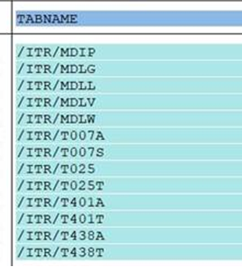

MDIP MRP Profiles
T401A MRP profiles (definition)
T401T MRP Profile Descriptions
MDLG MRP Area Storage Location
MDLL MRP Area Subcontractor
MDLV MRP Area
MDLW MRP Area Plants
T007A Tax Code
T007S Tax Code Description
T025 Valuation Class
T025T Valuation Class Description
T438A MRP Type
T438T MRP Type Description

Test: Snapshot creation / compare / restore

